Möbius Strip DIAGRAMS ???

1) Take a long, thin strip of paper. Put one twist in it. Glue the two ends together. This is a Möbius strip. Try painting one side of the Möbius strip red and the other side blue.

2) Take a long, thin strip of paper and draw a dotted line along the length. Put one twist in it. Glue the two ends together. Now cut along the dotted line.
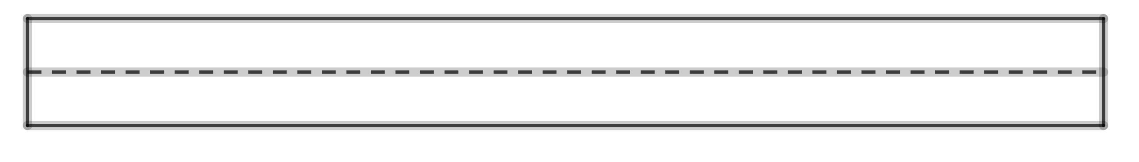
3) Take a long, thin strip of paper and draw two dotted lines along the length. Put one twist in it. Glue the two ends together. Now cut along the dotted line.
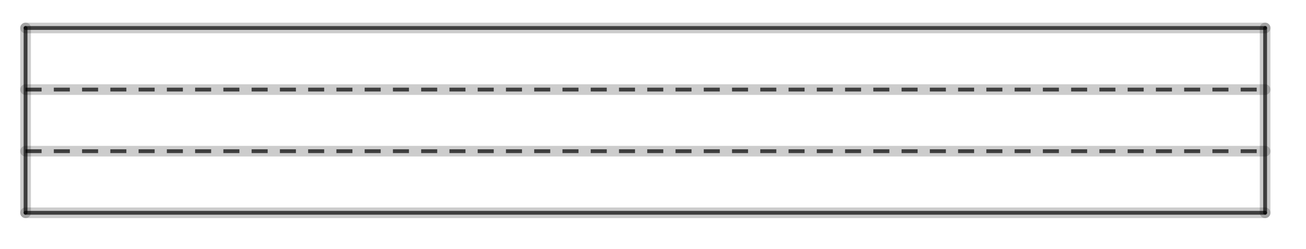
4) Play around. Try putting two twist in the strip of paper. Try drawing three dotted lines. etc

